MSc BDS – Data Engineering and Machine Learning Operations in Business

MLOps Final Assignment:
AI-Driven Retail Demand Forecasting and Smart Inventory Optimization

Submitted by: Anzuman Ara
Student ID: 20241266

Submission Deadline: May 26, 2026

1. Introduction and Aim of the Project
Machine learning models are often developed and evaluated in controlled environments, but real-world business systems continuously evolve due to operational changes, seasonal trends, customer behavior, and external business factors. In retail environments, product demand changes frequently depending on promotions, holidays, weather conditions, and inventory availability. Therefore, machine learning systems must not only generate predictions but also support continuous monitoring, retraining, deployment, and operational reliability.
This project follows core MLOps principles, focusing not only on model development but also on deployment, monitoring, reproducibility, and production-oriented system design.
The aim of this project is to design and implement an AI-driven MLOps system for retail demand forecasting and smart inventory optimization in retail environments.
This project also connects inventory optimization with societal well-being. In retail businesses, inaccurate demand forecasting can lead to overstocking, product expiry, and avoidable food waste. By predicting demand more accurately and identifying high waste-risk inventory situations, the system can support better stock planning, reduce unnecessary surplus, and help retailers make more responsible inventory decisions. Although the waste-related variables in this project are simulated for demonstration purposes, the implemented workflow shows how machine learning and MLOps practices can be used to support food waste reduction in real retail environments.
The project focuses on predicting future product demand using historical retail sales data and identifying situations where excess inventory may increase the risk of food waste. In real retail operations, supermarkets often experience inventory loss due to overstocking, inaccurate demand forecasting, short product shelf life, and changing customer purchasing behavior.
To address this problem, the project combines historical Walmart retail sales data with a production-like API-based data pipeline. The system continuously receives sales events through APIs, preprocesses incoming data, performs feature engineering, trains machine learning models, generates demand predictions, calculates waste risk levels, and supports monitoring and retraining.
Additionally, this project was designed as a production-oriented MLOps implementation rather than a notebook-only machine learning experiment. Therefore, the system includes API-based data ingestion, database storage, preprocessing automation, model training, prediction serving, logging, drift detection, retraining, artifact storage, and dashboard visualization.

2. Pipeline Diagram
External Retail System (Simulated)
↓ POST /sales-event
FastAPI Ingestion API
↓
SQLite Database (raw_food_sales table)
↓
/run-pipeline API
↓
Preprocessing + Feature Engineering
↓
Demand Forecasting Model Training
↓
Model Registry + Artifacts
↓
POST /predict-demand
↓
Prediction Logs + Waste Risk Output
↓
Drift Detection
↓
If Drift → Auto Retraining
↓
Streamlit Dashboard
Figure 1: End-to-end MLOps pipeline architecture for food waste prediction and inventory optimization.
The pipeline simulates a production-style retail MLOps workflow where external inventory events are ingested through APIs, processed inside the ML pipeline, monitored for drift, and retrained automatically when operational changes occur.

3. Technical Details of Each Pipeline Component
3.1 Real-Time Data Ingestion
The data ingestion component was redesigned to simulate a production-oriented retail workflow. Instead of directly inserting records into the database through standalone scripts, the system uses API-based ingestion.
An external client simulates a supermarket operational system by generating sales and inventory events and sending them to the FastAPI backend through the /sales-event endpoint.
The external_client.py module simulates an external retail system that continuously sends live inventory and sales events to the FastAPI backend through HTTP POST requests. This architecture demonstrates a production-oriented API ingestion workflow instead of directly inserting records into the database through standalone scripts.
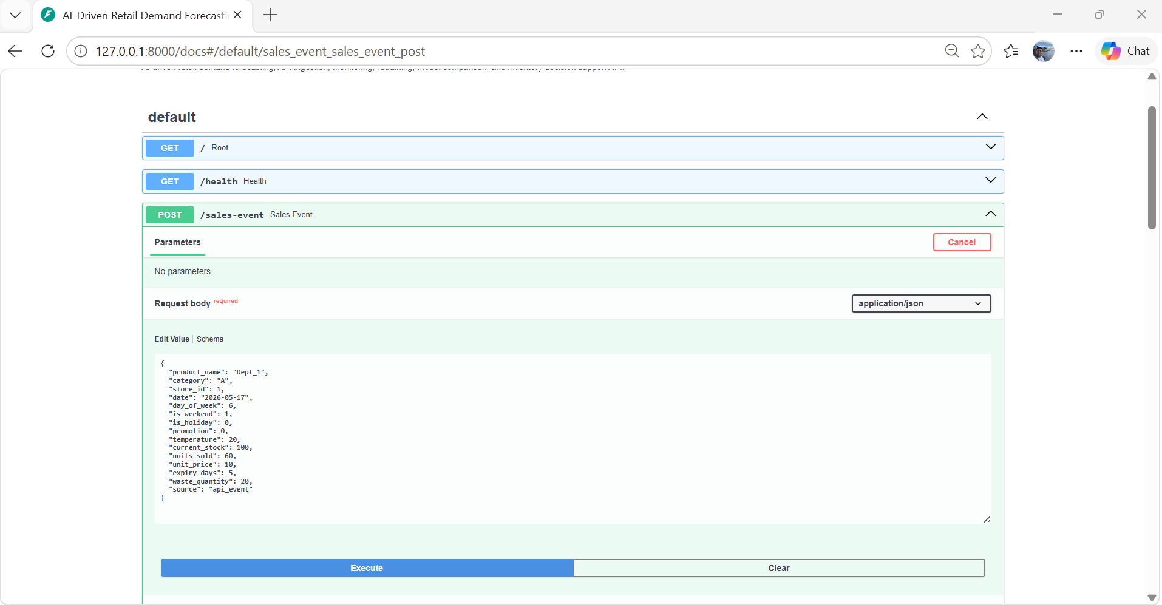
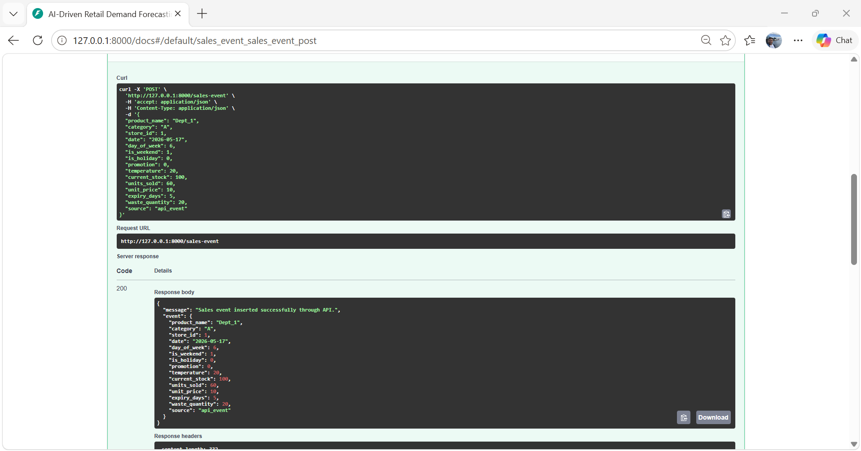
Figure 2: Production-style API ingestion workflow using the FastAPI /sales-event endpoint.
Each generated retail event is validated by the FastAPI backend and then stored inside the SQLite raw_food_sales table. This simulates how real retail systems continuously stream operational inventory data into machine learning pipelines.
The FastAPI API validates incoming data using structured schemas and stores the validated records inside the SQLite raw_food_sales table.
The Walmart Store Sales Forecasting dataset from Kaggle was integrated into the system as historical training data. The dataset contains historical sales information across multiple Walmart stores and departments, including holiday-related effects and operational retail features.
Additional API endpoints such as /latest-sales were implemented to support production-like ingestion and data validation workflows.
The Walmart Store Sales Forecasting dataset was used as the primary historical retail demand dataset. Since the dataset does not contain real inventory expiry or food waste information, additional inventory-related variables such as current_stock, expiry_days, unit_price, and waste_quantity were synthetically generated to simulate inventory optimization and waste-risk analysis workflows within a production-oriented MLOps environment.
3.2 Preprocessing
The preprocessing stage ensures consistency between training and inference.
The preprocessing pipeline reads sales records directly from the SQLite database and performs several transformation and cleaning operations before model training.
The following preprocessing steps are applied:
• missing value handling
• numerical type conversion
• duplicate removal
• categorical encoding
• invalid value handling
• outlier safety handling
• feature engineering
SQLite was selected because it provides lightweight structured storage and integrates easily with Python-based machine learning pipelines.
Consistent preprocessing is important in MLOps systems because training-serving mismatch may reduce prediction reliability. Therefore, the same preprocessing logic is reused during both training and prediction stages.
3.3 Feature Engineering
Feature engineering was applied to capture inventory behavior, sales patterns, operational conditions, and food waste risk.
The following engineered features were created:
- product_encoded
This feature converts Walmart department identifiers into numerical values so that machine learning models can process product-level retail patterns.
- category_encoded
This feature converts retail category labels into numerical representations to capture operational differences between store categories.
- short_expiry
This binary feature identifies products with limited remaining shelf life. Products with shorter expiry periods have higher probability of becoming unsold inventory and contributing to potential food waste.
- promotion_active
This feature identifies whether promotional campaigns are active. Promotions may temporarily increase customer demand and reduce the probability of overstock-related waste.
- is_weekend
This feature captures weekend purchasing behavior because retail demand often changes during weekends compared to weekdays.
- day_of_week
This feature captures daily purchasing patterns across the retail week to improve forecasting consistency.
- stock_to_sales_ratio
This engineered feature measures the relationship between current inventory and recent sales activity. Higher ratios may indicate overstock situations that could increase waste risk.
- waste_risk_score
This feature combines inventory level, demand level, and expiry-related conditions into a simplified operational waste-risk indicator for inventory monitoring.
These engineered features were selected because they help capture operational retail behavior, inventory conditions, and demand-related business patterns.
The same feature engineering logic is reused during both training and prediction to reduce training-serving skew.
3.4 Model Training
A Random Forest regression model was selected for demand forecasting because it performs effectively on structured retail datasets and can capture non-linear operational relationships.
The target variable used for training is units_sold, representing future product demand.
The training pipeline begins by loading the processed dataset and separating the target variable from input features. The dataset is then divided into training and testing subsets using train_test_split to evaluate model performance on unseen records.
After training, the model generates predictions on the test set.
The model is evaluated using:
• MAE (Mean Absolute Error)
• RMSE (Root Mean Squared Error)
• R² Score
MAE measures average prediction error, RMSE penalizes larger prediction errors, and R² evaluates how well the model explains demand variability. After successful training, artifacts including trained models, feature schemas, and evaluation metrics are stored for reproducibility and deployment.
Structured artifact storage was implemented to organize trained models, metrics, drift reports, and monitoring outputs.
4. Evaluation, Monitoring, and Versioning Strategy
4.1 Evaluation
Model performance is evaluated using multiple regression metrics including MAE, RMSE, and R² Score.
The latest training run achieved:
• MAE ≈ 253
• RMSE ≈ 704
• R² ≈ 0.90
The evaluation metrics were calculated using predictions generated on the testing subset after the train-test split process. The model performance was evaluated by comparing predicted units_sold values against actual units_sold values from unseen retail records. Scikit-learn evaluation functions including mean_absolute_error, mean_squared_error, and r2_score were used to calculate the final regression performance metrics.
Using multiple evaluation metrics improves model assessment compared to relying on a single metric alone.
4.2 Monitoring
Monitoring is implemented at multiple operational levels.
First, prediction logs are stored to maintain traceability of predictions, timestamps, waste risk outputs, and inventory recommendations.
Second, ingestion activity is monitored through incoming records stored in the raw_food_sales table.
Third, automated drift detection was implemented to monitor changes in retail operational behavior over time.
In real-world retail environments, customer purchasing behavior, product demand, inventory levels, and seasonal patterns continuously change. As a result, the statistical distribution of incoming operational data may gradually differ from the historical training data used by the machine learning model. This problem is commonly referred to as data drift.
To address this issue, the system performs numerical feature drift detection using relative mean shift analysis.
The following operational features are monitored:
• units_sold
• current_stock
• temperature
• waste_quantity
The drift detection process compares historical reference data with newly incoming retail data batches.
For each monitored feature, the system calculates the relative difference between historical mean values and recent incoming mean values. If the drift score exceeds a predefined threshold (0.20), the system identifies the feature as drifted and generates a drift report.
This approach helps detect operational changes such as:
• unusual sales spikes
• abnormal inventory behavior
• changing temperature conditions
• sudden increases in food waste levels
If significant drift is detected, the system can automatically trigger retraining using updated retail data. This helps maintain model reliability and prediction quality over time.
The drift reports are stored inside the drift_reports table and can also be visualized through the Streamlit dashboard for monitoring purposes.
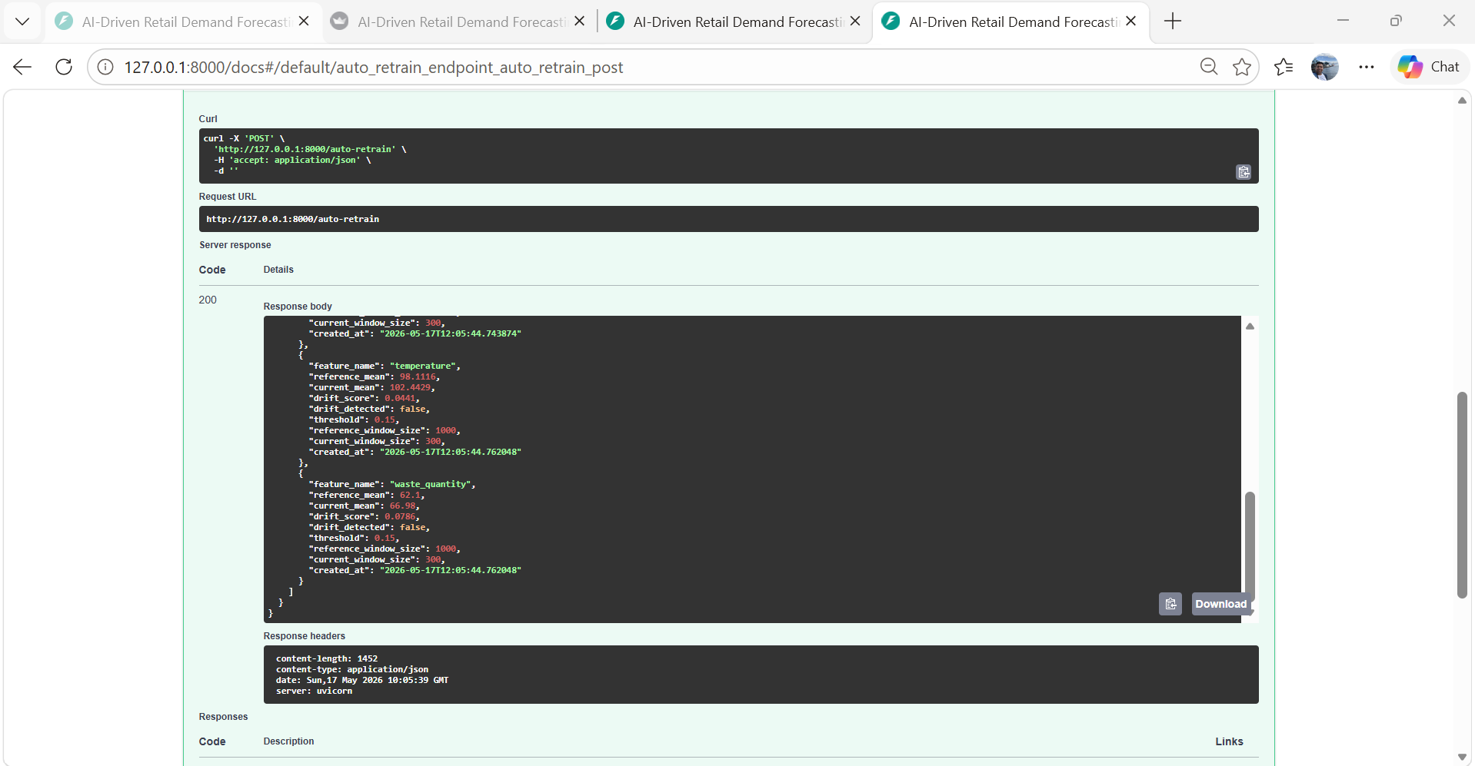
Figure 3: Drift monitoring output showing operational distribution changes across monitored retail features.
The monitoring workflow calculates drift scores by comparing historical and current feature distributions. If any monitored feature exceeds the threshold, the system flags operational drift and can trigger automatic retraining.
The auto_retrain.py workflow automatically checks whether operational drift exceeds the configured threshold. If significant drift is detected, preprocessing and model retraining are executed automatically. Otherwise, retraining is skipped to avoid unnecessary computational overhead.
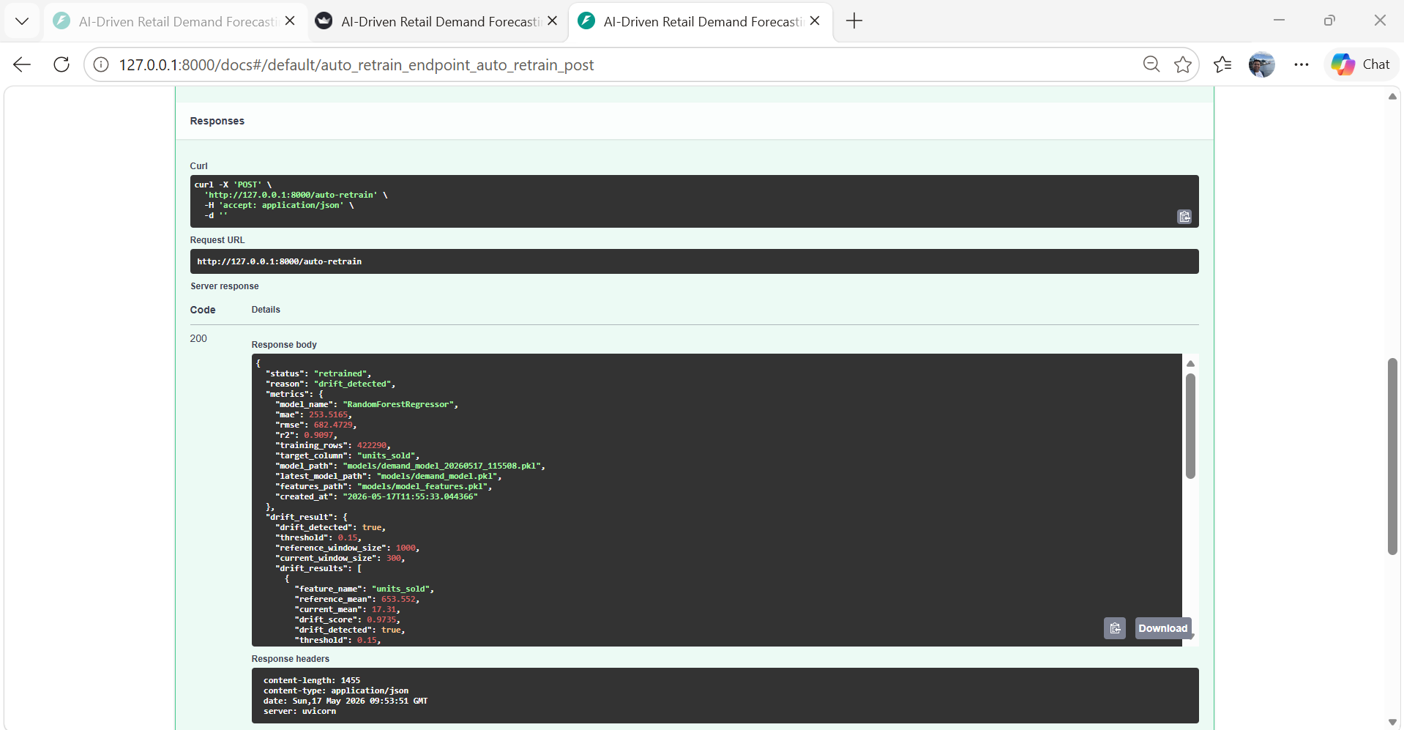
Figure 4: Automatic retraining workflow based on drift monitoring results.
To validate the monitoring workflow, shifted operational retail events were intentionally injected into the system through the API ingestion pipeline. The resulting distribution changes triggered the drift detection mechanism and automatically activated the retraining workflow. This experiment demonstrates how the system can adapt to changing operational retail conditions through monitoring-driven retraining.
4.3 Versioning
Artifact organization and lightweight version tracking were implemented using structured artifact storage and a SQLite model registry table.
Each successful training run stores:
• trained model files
• feature schema files
• evaluation metric files
• prediction logs
• drift reports
A lightweight model registry table was also implemented inside SQLite to track model versions, timestamps, and performance metrics.
Versioning supports reproducibility, rollback, debugging, and model comparison across multiple training runs.

5. Artifact Collection and Storage
Artifact management improves reproducibility, auditability, and operational reliability within machine learning systems.
Artifacts are stored inside structured directories to maintain separation between models, logs, processed data, and monitoring outputs.
Stored artifacts include:
• raw historical retail data
• processed datasets
• trained model files
• evaluation metrics
• feature schema files
• prediction logs
• drift reports
• retraining outputs
This storage strategy supports reproducibility by making it possible to recreate previous experiments and compare model performance across different pipeline executions.
The artifact strategy also improves debugging and operational traceability.
Artifact | Purpose
demand_model.pkl | Trained forecasting model
model_features.pkl | Feature schema
drift_summary.csv | Drift monitoring results
model_metrics.csv | Model evaluation metrics
training_summary.json | Training configuration
ingestion_log.csv | API ingestion history
retraining_log.csv | Retraining decisions

6. Deployment Setup
6.1 API Deployment
The trained model was deployed using FastAPI. FastAPI was selected because it is lightweight, high-performance, and suitable for serving machine learning models through REST APIs. The FastAPI backend exposes production-style REST API endpoints for ingestion, prediction, monitoring, drift detection, retraining, and pipeline execution. Swagger documentation was automatically generated to support endpoint testing and API inspection.
The system exposes multiple endpoints including:
• /sales-event
• /predict-demand
• /run-pipeline
• /prediction-logs
• /drift-check
• /drift-reports
• /auto-retrain
• /model-info
These endpoints support both prediction and operational monitoring.
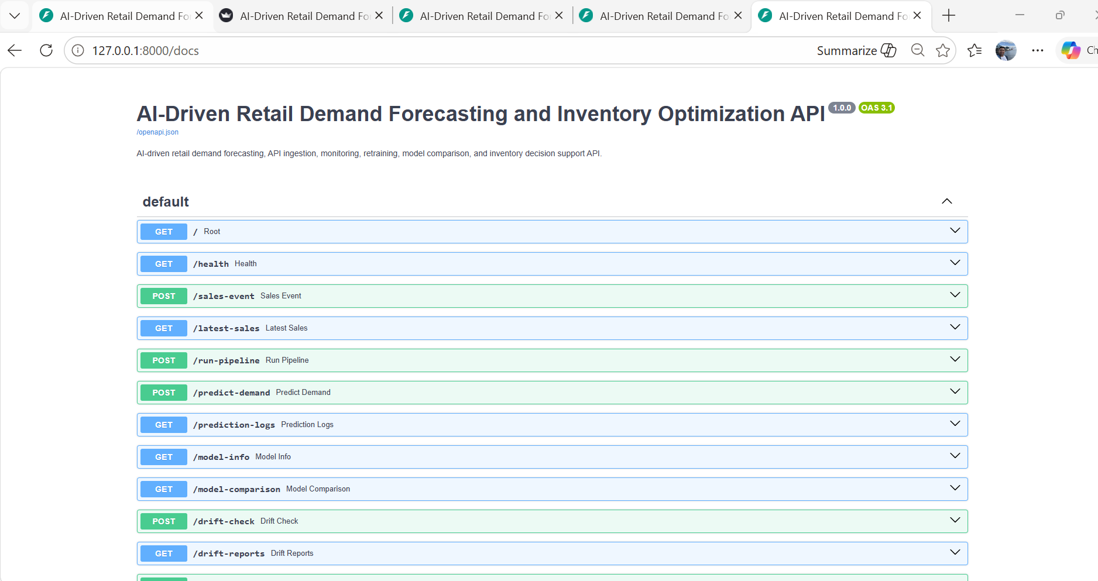
Figure 5: FastAPI Swagger documentation showing deployed API endpoints.
The deployed API allows external systems and dashboards to interact with the machine learning pipeline through standardized HTTP endpoints.
6.2 Docker Deployment
The application supports Docker-based deployment to improve portability and deployment consistency across environments.
Docker packages the application code, dependencies, and runtime configuration into a single container image.
This reduces environment-related deployment issues and improves reproducibility.
6.3 Execution Mode
The system supports multiple execution modes.
First, real-time demand prediction is available through the FastAPI backend.
Second, the Streamlit dashboard allows interactive prediction and monitoring.
Third, automated retraining workflows can be triggered using updated incoming retail data.
This combination creates a realistic production-oriented MLOps workflow.

7. Frontend
A Streamlit dashboard was implemented to support both prediction and system monitoring.
The frontend allows users to:
• submit product inventory information
• predict future demand
• view waste risk level
• receive inventory recommendations
• monitor prediction logs
• monitor drift reports
• check model information
The frontend communicates with the FastAPI backend using HTTP requests.
Prediction outputs displayed in the dashboard include:
• predicted demand
• waste risk score
• inventory recommendation
• monitoring outputs
The dashboard improves usability for both technical users and business decision-makers by providing interactive visualization and operational transparency.
The Streamlit dashboard provides a user-friendly interface for interacting with the deployed machine learning system. Users can enter product and inventory information, request demand predictions, view waste risk levels, and receive inventory recommendations without directly interacting with the backend code.
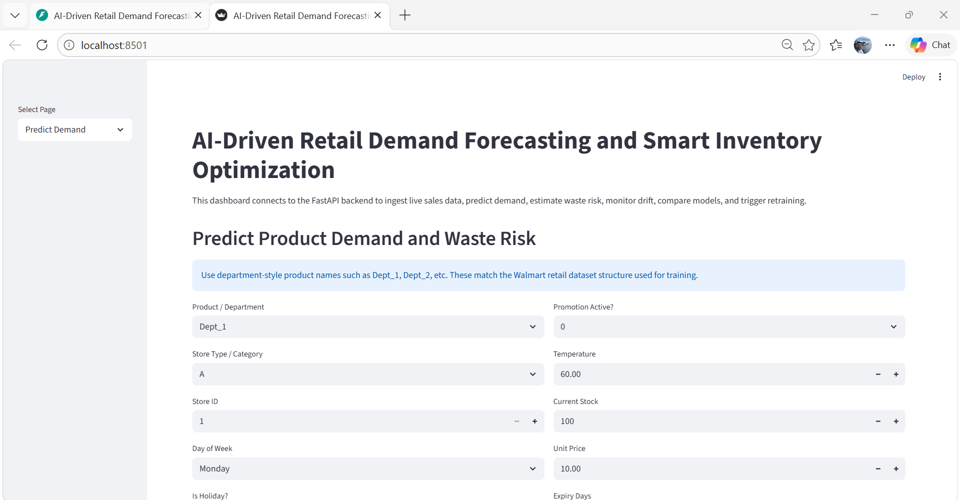
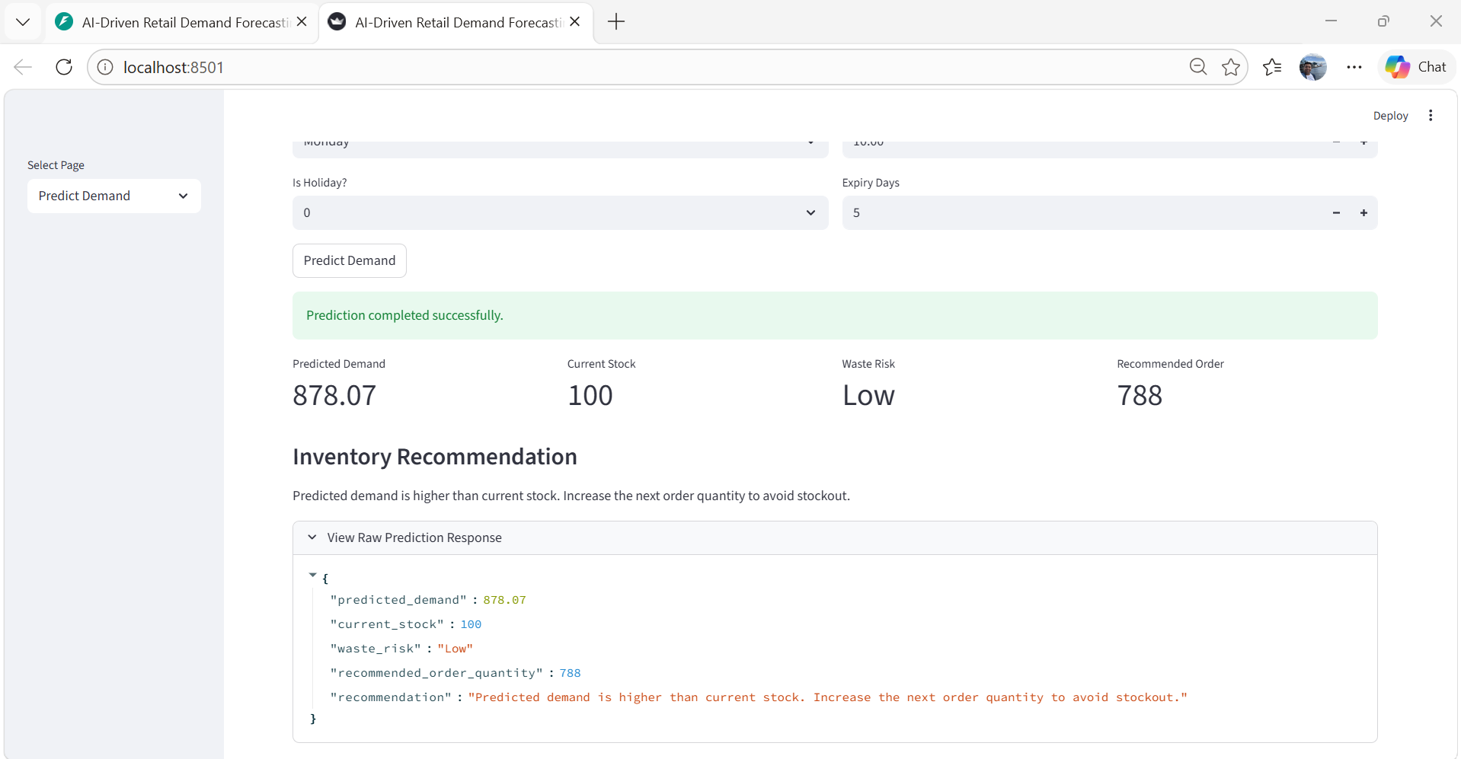
Figure 6: Streamlit dashboard showing demand prediction, waste risk level, and inventory recommendation.
The prediction interface demonstrates how machine learning outputs can support inventory optimization decisions in retail environments. By estimating future demand and identifying high waste-risk inventory situations, the system can help reduce unnecessary overstocking and improve stock planning efficiency. This type of operational forecasting may contribute to reducing avoidable food waste and improving resource utilization within retail supply chains.
A GitHub Actions workflow was added to support triggered pipeline validation and automated source-code checks during repository updates.

Figure 7: GitHub Actions workflow execution showing successful automated pipeline validation.

8. Conclusion
This project demonstrated a production-oriented MLOps pipeline for retail demand forecasting and smart inventory optimization. The implementation combined API-based ingestion, preprocessing, feature engineering, machine learning-based demand forecasting, monitoring, drift detection, retraining, deployment, and dashboard visualization within a unified workflow.
Unlike notebook-only machine learning experiments, the system simulated a realistic operational environment where retail inventory events continuously flow through ingestion, prediction, monitoring, and retraining pipelines.
The implementation also demonstrated how demand forecasting and inventory optimization can support better stock planning and help reduce potential overstock-related food waste. By identifying high waste-risk inventory situations and generating inventory recommendations, the system illustrated how MLOps practices may contribute to operational efficiency and societal well-being within retail supply chains.

References
Kreuzberger, D., Kühl, N., & Hirschl, S. (2023). Machine Learning Operations (MLOps): Overview, Definition, and Architecture. IEEE Access, 11, 31866–31879.
Schlegel, M., & Sattler, K.-U. (2022). Management of Machine Learning Lifecycle Artifacts: A Survey. SIGMOD Record, 51(4), 18–35.
Zha, D., Bhat, Z. P., Lai, K.-H., et al. (2025). Data-centric Artificial Intelligence: A Survey. ACM Computing Surveys, 57(5), Article 129.

